Leung, Cristian K (Student)
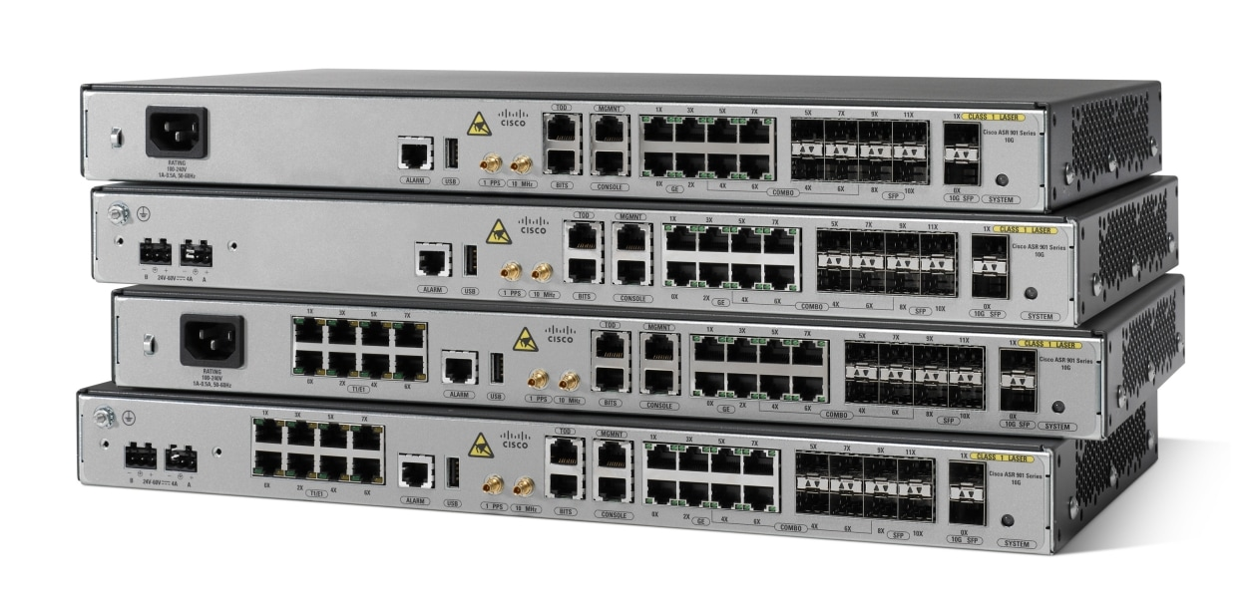

BGP Lab

Purpose
The purpose of this lab was to learn how to set up BGP protocol and to figure out how to let the routers communicate while running different interior gateway routing protocols.

Background Information
BGP or Border gateway protocol is a protocol that is used to decide how data travels over large networks, focused on what path to take to get to the destination. It is different from EIGRP, OSPF, and IS-IS because it’s used to route between networks rather than in a network. It’s also slow compared to the other protocols because it focuses mainly on stability over speed because internet wide changes must be controlled.
Before BGP during the 1970’s – 1980’s the internet was pretty small and basically one big network. Routing between these networks was handled by EGP (Exterior Gateway Protocol), but EGP has a lot of limits. It couldn’t scale as the internet started exploding in growth. By end of 1980s EGP couldn’t handle the speed at which it was growing. Researchers Yakov Rekhter and Kirk Lougheed invented a new protocol BGP to replace it. BGP was launched in 1989, designed to support multiple interconnected networks. This was when the internet started changing from a centralized system to a cooperative one. To this day BGP is widely used and that’s mainly thanks to it’s scalability and how it adapted over the years, getting a lot of small improvements from time to time like improving it’s stability.
IS-IS is a routing protocol that helps figure out the best path within a single network. Routers that are running IS-IS share information to create a network topology to forward traffic efficiently. It’s mainly used in larger networks or service providers thanks to its fast convergence, predictable scaling, and solid stability. OSPF on the other hand is used for smaller networks since its really straightforward and easy to troubleshoot compared to IS-IS.
EIGRP is another routing protocol developed by Cisco which is used mainly for it’s failover in case of issues and ability to do unequal cost balancing which helps distribute traffic. Nowadays it’s mainly only used for Cisco heavy networks.
Ipv4 and ipv6 are two different version so internet protocols. Think of it as like addresses or ID’s for devices. Ipv4 uses 32-bit addresses and is the more widely used IP version but eventually it is starting to run out of addresses, so some have started using ipv6 which uses 128 bit addresses which is basically unlimited, addressing the issue of running out.

Topology
IPv4
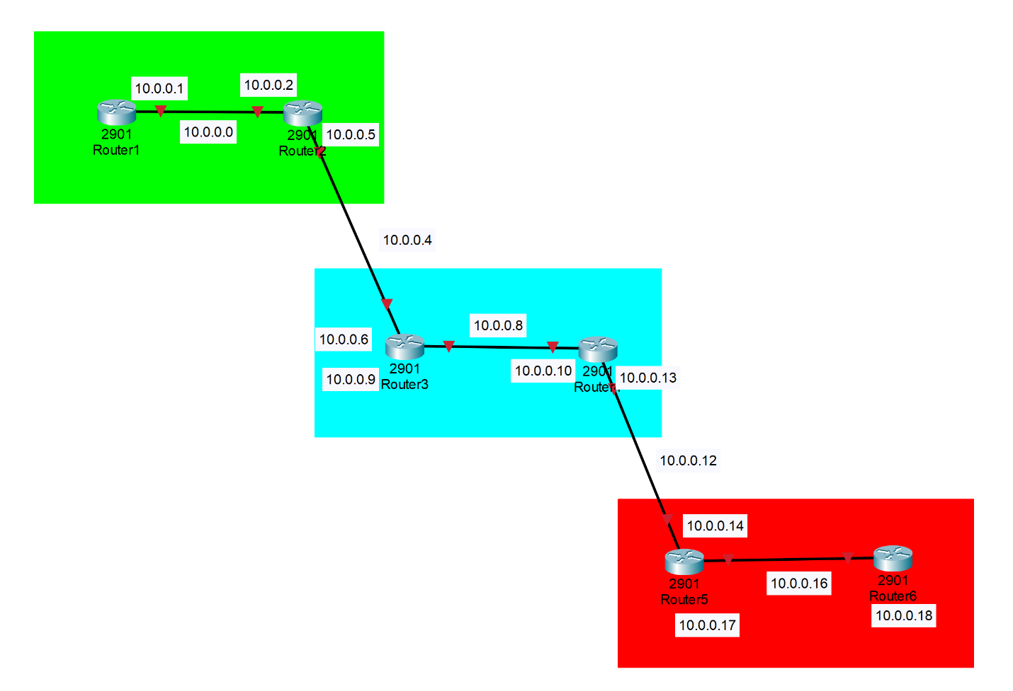
IPv6
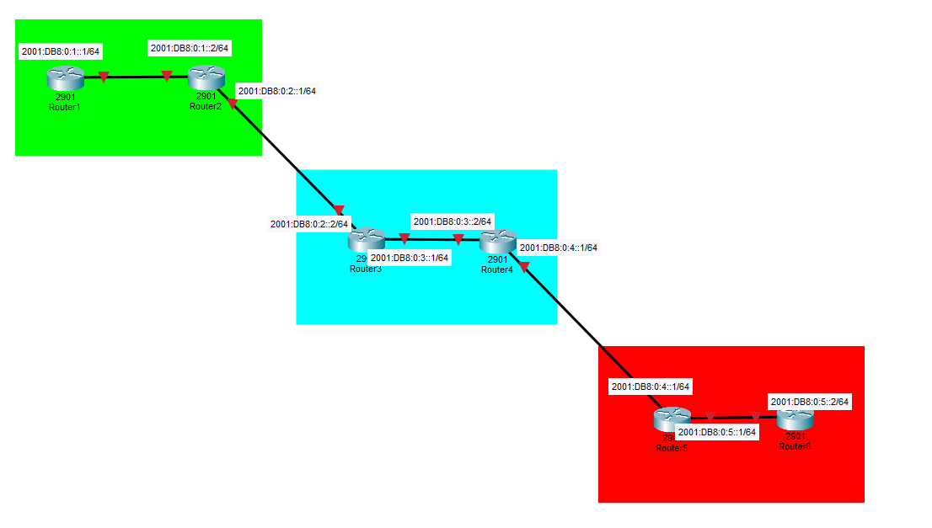

Lab Summary
Address table (Example IP’s that we used for our lab)
Device name | Interface | IPv4 address | Subnet mask | IPv6 address
R1 | G0/1 | 10.0.0.1 | 255.255.255.252 | 2001:DB8:0:1::1/64
R2 | G0/0 | 10.0.0.2 | 255.255.255.252 | 2001:DB8:0:1::2/64
R2 | G0/1 | 10.0.0.5 | 255.255.255.252 | 2001:DB8:0:2::1/64
R3 | G0/0 | 10.0.0.6 | 255.255.255.252 | 2001:DB8:0:2::2/64
R3 | G0/1 | 10.0.0.9 | 255.255.255.252 | 2001:DB8:0:3::1/64
R4 | G0/0 | 10.0.0.10 | 255.255.255.252 | 2001:DB8:0:3::2/64
R4 | G0/1 | 10.0.0.13 | 255.255.255.252 | 2001:DB8:0:4::1/64
R5 | G0/0 | 10.0.0.14 | 255.255.255.252 | 2001:DB8:0:4::2/64
R5 | G0/1 | 10.0.0.17 | 255.255.255.252 | 2001:DB8:0:5::1/64
R6 | G0/0 | 10.0.0.18 | 255.255.255.252 | 2001:DB8:0:5::2/64

Lab Commands
Common commands | Description
Hostname <name> | Sets the router’s device name.
ipv6 unicast-routing | Enables IPv6 routing on the router.
interface <interface number> | Enters interface configuration mode
ip address <ip address> <subnet mask> | Designates IPv4 addresses and subnet mask.
ipv6 address address <ipv6 address>/<CIDR> | Designates IPv6 addresses and subnet.

Router 1 commands | Description
router ospf <#> | Starts OSPF process #.
router-id X.X.X.X | Manually sets the OSPF Router ID.
network <ip address> <wildcard mask> area <#> | Enables OSPF on matching interfaces.
ipv6 router ospf # | Starts OSPFv3 process #
ipv6 ospf # area # | Assigns an interface to use OSPF #

Router 2 commands | Description
router ospf <#> | Starts OSPF process #.
router-id X.X.X.X | Manually sets the OSPF Router ID.
network <ip address> <wildcard mask> area <#> | Enables OSPF on matching interfaces.
ipv6 router ospf # | Starts OSPFv3 process #.
ipv6 ospf # area # | Assigns an interface to use OSPF #.
router bgp <AS> | Starts BGP for the given AS.
bgp router-id 2.2.2.2 | Sets BGP router ID.
neighbor <IP address> remote-as <AS> | Defines an IPv4 BGP neighbor for connectivity.
neighbor <IPv6 address> remote-as <AS> | Defines an IPv6 BGP neighbor for connectivity.
address-family ipv4 | Enters IPv4 BGP configuration mode.
address-family ipv6 | Enters IPv6 BGP configuration mode.
redistribute connected | Injects connected routes into BGP
redistribute ospf 1 | Injects OSPF routes into BGP
neighbor <IPv4 or IPv6> activate | Enables BGP for that neighbor in the address family.
exit-address-family | Exits IP BGP configuration mode.

Router 3 commands | Description
router eigrp <AS> | Starts EIGRP AS.
network <IP address> <wildcard bit> | Enables EIGRP on interfaces matching the network.
redistribute bgp <AS> metric <BW> <DLY> <REL> <LOAD> <MTU> | Injects BGP routes into EIGRP.
eigrp router-id X.X.X.X | Sets EIGRP router ID.
ipv6 eigrp 1 | Enables IPv6 EIGRP on interface.
router bgp <AS> | Starts BGP for the given AS.
bgp router-id 2.2.2.2 | Sets BGP router ID.
neighbor <IP address> remote-as <AS> | Defines an IPv4 BGP neighbor for connectivity.
neighbor <IPv6 address> remote-as <AS> | Defines an IPv6 BGP neighbor for connectivity.
address-family ipv4 | Enters IPv4 BGP configuration mode.
address-family ipv6 | Enters IPv6 BGP configuration mode.
redistribute connected | Injects connected routes into BGP
redistribute eigrp 1 | Injects EIBRP routes into BGP
neighbor <IPv4 or IPv6> activate | Enables BGP for that neighbor in the address family.
exit-address-family | Exits IP BGP configuration mode.
ip prefix-list <name> seq 5 permit 0.0.0.0/0 le 32 (OPTIONAL) | Creates a list that permits all matched IPv4 routes.
route-map <name> permit 20 (OPTIONAL) | Creates a routing policy.
set local-preference 200 (OPTIONAL) | Sets BGP local preference. (Higher is more preferred.)
match ip address prefix-list <name> (OPTIONAL) | Matches the routing policy to the prefix list.
neighbor <IP> route-map <Route-map name> in (OPTIONAL) | Applies route-map routing policy to the neighbor.

Router 4 commands | Description
router eigrp <AS> | Starts EIGRP AS.
network <IP address> <wildcard bit> | Enables EIGRP on interfaces matching the network.
redistribute bgp <AS> metric <BW> <DLY> <REL> <LOAD> <MTU> | Injects BGP routes into EIGRP.
eigrp router-id X.X.X.X | Sets EIGRP router ID.
ipv6 eigrp 1 | Enables IPv6 EIGRP on interface.
router bgp <AS> | Starts BGP for the given AS.
bgp router-id X.X.X.X | Sets BGP router ID.
neighbor <IP address> remote-as <AS> | Defines an IPv4 BGP neighbor for connectivity.
neighbor <IPv6 address> remote-as <AS> | Defines an IPv6 BGP neighbor for connectivity.
address-family ipv4 | Enters IPv4 BGP configuration mode.
address-family ipv6 | Enters IPv6 BGP configuration mode.
redistribute connected | Injects connected routes into BGP
redistribute eigrp 1 | Injects EIBRP routes into BGP
neighbor <IPv4 or IPv6> activate | Enables BGP for that neighbor in the address family.
exit-address-family | Exits IP BGP configuration mode.

Router 5 commands | Description
router isis | Starts IS-IS routing process.
net 49.XXXX.XXXX.XXXX.XXXX.XX | Sets the IS-IS NET (Network Entity Title).
is-type level-1 | Configures to only operate as a Level-1 Router.
metric-style wide | Enables modern wide metrics.
redistribute bgp 3 metric 30 level-1 | Injects BGP routes into IS-IS level 1.
ip router isis | Enables IS-IS for IPv4 on an interface.
ipv6 router isis | Enables IS-IS for IPv6 on an interface.
router bgp <AS> | Starts BGP for the given AS.
bgp router-id X.X.X.X | Sets BGP router ID.
neighbor <IP address> remote-as <AS> | Defines an IPv4 BGP neighbor for connectivity.
neighbor <IPv6 address> remote-as <AS> | Defines an IPv6 BGP neighbor for connectivity.
address-family ipv4 | Enters IPv4 BGP configuration mode.
address-family ipv6 | Enters IPv6 BGP configuration mode.
redistribute connected | Injects connected routes into BGP
redistribute isis level-1 metric 10 | Injects IS-IS routes into BGP
redistribute bgp 3 metric 30 level-1 | Injects BGP routes into IS-IS Level-1
neighbor <IPv4 or IPv6> activate | Enables BGP for that neighbor in the address family.
exit-address-family | Exits IP BGP configuration mode.

Router 6 commands | Description
router isis | Starts IS-IS routing process.
net 49.XXXX.XXXX.XXXX.XXXX.XX | Sets the IS-IS NET (Network Entity Title).
is-type level-1 | Configures to only operate as a Level-1 Router.
metric-style wide | Enables modern wide metrics.
redistribute bgp 3 metric 30 level-1 | Injects BGP routes into IS-IS level 1.
ip router isis | Enables IS-IS for IPv4 on an interface.
ipv6 router isis | Enables IS-IS for IPv6 on an interface.

Lab Config
Follow the configurations below by using the commands listed above for their respective devices. Once finished you can use show run to double check if you miss any. It should look the same as the configurations listed below.

Router 1:
version 15.2
!
hostname R1
!
!
ipv6 unicast-routing
!
interface Loopback0
ip address 1.1.1.1 255.255.255.255
!
interface GigabitEthernet0/0
no ip address
duplex auto
speed auto
!
interface GigabitEthernet0/1
ip address 10.0.0.1 255.255.255.252
ip ospf dead-interval 6
ip ospf hello-interval 2
duplex auto
speed auto
ipv6 address 2001:DB8:0:1::1/64
ipv6 ospf 1 area 0
!
router ospf 1
router-id 1.1.1.1
network 1.1.1.1 0.0.0.0 area 0
network 2.2.2.2 0.0.0.0 area 0
network 10.0.0.0 0.0.0.3 area 0
network 10.0.0.4 0.0.0.3 area 0
!
ipv6 router ospf 1
router-id 1.1.1.1
!
!
end

Router 2:
version 15.4
!
hostname router2
!
interface GigabitEthernet0/0
ip address 10.0.0.2 255.255.255.252
duplex auto
speed auto
ipv6 address 2001:DB8:0:1::2/64
ipv6 ospf 1 area 0
!
interface GigabitEthernet0/1
ip address 10.0.0.5 255.255.255.252
duplex auto
speed auto
ipv6 address 2001:DB8:0:2::1/64
!
router ospf 1
router-id 2.2.2.2
redistribute bgp 1 metric 10 subnets
network 10.0.0.0 0.0.0.3 area 0
network 10.0.0.4 0.0.0.3 area 0
network 10.0.0.12 0.0.0.3 area 0
!
router bgp 1
bgp router-id 2.2.2.2
bgp log-neighbor-changes
neighbor 10.0.0.6 remote-as 2
neighbor 2001:DB8:0:2::2 remote-as 2
!
address-family ipv4
redistribute connected
redistribute ospf 1
neighbor 10.0.0.6 activate
no neighbor 2001:DB8:0:2::2 activate
exit-address-family
!
address-family ipv6
redistribute connected
redistribute ospf 1 metric 10
neighbor 2001:DB8:0:2::2 activate
exit-address-family
!
ipv6 router ospf 1
router-id 2.2.2.2
redistribute bgp 1 metric 10
!
!
end

Router 3:
version 15.4
hostname router3
ipv6 unicast-routing
!
!
interface GigabitEthernet0/0
ip address 10.0.0.9 255.255.255.252
duplex auto
speed auto
ipv6 address 2001:DB8:0:3::1/64
!
interface GigabitEthernet0/1
ip address 10.0.0.6 255.255.255.252
duplex auto
speed auto
ipv6 address 2001:DB8:0:2::2/64
ipv6 eigrp 1
!
!
router eigrp 1
network 10.0.0.4 0.0.0.3
network 10.0.0.8 0.0.0.3
redistribute bgp 2 metric 100 1 255 1 1500
eigrp router-id 3.3.3.3
!
router bgp 2
bgp router-id 3.3.3.3
bgp log-neighbor-changes
neighbor 10.0.0.5 remote-as 1
neighbor 2001:DB8:0:2::1 remote-as 1
!
address-family ipv4
redistribute connected
redistribute eigrp 1
neighbor 10.0.0.5 activate
neighbor 10.0.0.5 weight 200
neighbor 10.0.0.5 route-map jeffreymap in
no neighbor 2001:DB8:0:2::1 activate
exit-address-family
!
address-family ipv6
redistribute connected
redistribute eigrp 1
neighbor 2001:DB8:0:2::1 activate
exit-address-family
!
!
!
ip prefix-list jeffrey seq 5 permit 0.0.0.0/0 le 32
ipv6 router eigrp 1
eigrp router-id 3.3.3.3
redistribute bgp 2 metric 100 1 255 1 1500
!
!
route-map jeffreymap permit 20
match ip address prefix-list jeffrey
set local-preference 200
!
end

Router 4:
version 15.2
!
ipv6 unicast-routing
!
interface Loopback0
ip address 4.4.4.4 255.255.255.255
!
interface GigabitEthernet0/0
ip address 10.0.0.13 255.255.255.252
duplex auto
speed auto
ipv6 address 2001:DB8:0:4::1/64
ipv6 eigrp 1
!
interface GigabitEthernet0/1
ip address 10.0.0.10 255.255.255.252
duplex auto
speed auto
ipv6 address 2001:DB8:0:3::2/64
ipv6 eigrp 1
!
!
router eigrp 1
network 4.4.4.4 0.0.0.0
network 10.0.0.8 0.0.0.3
network 10.0.0.12 0.0.0.3
redistribute bgp 2 metric 100 1 255 1 1500
eigrp router-id 4.4.4.4
!
router bgp 2
bgp router-id 4.4.4.4
bgp log-neighbor-changes
neighbor 10.0.0.14 remote-as 3
neighbor 2001:DB8:0:4::2 remote-as 3
!
address-family ipv4
redistribute connected
redistribute eigrp 1
neighbor 10.0.0.14 activate
neighbor 10.0.0.14 weight 200
no neighbor 2001:DB8:0:4::2 activate
exit-address-family
!
address-family ipv6
redistribute connected
redistribute eigrp 1
neighbor 2001:DB8:0:4::2 activate
exit-address-family
!
ip forward-protocol nd
!
no ip http server
no ip http secure-server
!
!
ipv6 router eigrp 1
eigrp router-id 4.4.4.4
redistribute bgp 2 metric 100 1 255 1 1500
!
end

Router 5:
version 15.4
!
hostname router5
!
ipv6 unicast-routing
!
interface Loopback0
ip address 5.5.5.5 255.255.255.255
ip router isis
!
interface GigabitEthernet0/0
ip address 10.0.0.17 255.255.255.252
ip router isis
duplex auto
speed auto
ipv6 address 2001:DB8:0:5::1/64
ipv6 router isis
!
interface GigabitEthernet0/1
ip address 10.0.0.14 255.255.255.252
ip router isis
duplex auto
speed auto
ipv6 address 2001:DB8:0:4::2/64
ipv6 router isis
!
router isis
net 49.0001.0000.0000.000a.00
is-type level-1
metric-style wide
log-adjacency-changes
redistribute bgp 3 metric 30 level-1
!
address-family ipv6
redistribute bgp 3 metric 30 level-1
exit-address-family
!
router bgp 3
bgp router-id 5.5.5.5
bgp log-neighbor-changes
no bgp default ipv4-unicast
neighbor 10.0.0.13 remote-as 2
!
address-family ipv4
redistribute connected
redistribute isis level-1 metric 10
neighbor 10.0.0.13 activate
exit-address-family
!
end

Router 6:
version 15.4
!
ipv6 unicast-routing
!
interface Loopback0
ip address 6.6.6.6 255.255.255.255
ip router isis
!
interface GigabitEthernet0/0
ip address 10.0.0.18 255.255.255.252
ip router isis
duplex auto
speed auto
ipv6 address 2001:DB8:0:5::2/64
ipv6 router isis
!
interface GigabitEthernet0/1
no ip address
duplex auto
speed auto
!
router isis
net 49.0001.0000.0000.000b.00
is-type level-1
metric-style wide
log-adjacency-changes
!
end

Show routes (Use “show ip route” to double check everything matches up with the text below):
Router 1:
C 1.1.1.1/32 is directly connected, Loopback0
C 10.0.0.0/30 is directly connected, Gi0/1
O E2 4.4.4.4/32 [110/10] via 10.0.0.2, Gi0/1
O E2 5.5.5.5/32 [110/10] via 10.0.0.2, Gi0/1
O E2 6.6.6.6/32 [110/10] via 10.0.0.2, Gi0/1
O E2 10.0.0.4/30 [110/10] via 10.0.0.2, Gi0/1
O E2 10.0.0.8/30 [110/10] via 10.0.0.2, Gi0/1
O E2 10.0.0.12/30 [110/10] via 10.0.0.2, Gi0/1
O E2 10.0.0.16/30 [110/10] via 10.0.0.2, Gi0/1
Router 2:
C 10.0.0.0/30 is directly connected, Gi0/0
L 10.0.0.1/30 is directly connected, Gi0/0
O 1.1.1.1/32 [110/10] via 10.0.0.1, Gi0/0

B 4.4.4.4/32 [20/0] via 10.0.0.6
B 5.5.5.5/32 [20/25600512] via 10.0.0.6
B 6.6.6.6/32 [20/25600512] via 10.0.0.6
C 10.0.0.4/30 is directly connected, Gi0/1
L 10.0.0.6/30 is directly connected, Gi0/1
B 10.0.0.8/30 [20/??] via 10.0.0.6
B 10.0.0.12/30 [20/??] via 10.0.0.6
B 10.0.0.16/30 [20/??] via 10.0.0.6
Router 3:
B 10.0.0.0/30 [20/0] via 10.0.0.6
C 10.0.0.4/30 is directly connected, GigabitEthernet0/1
L 10.0.0.5/30 is directly connected, Gi0/1
D EX 10.0.0.16/30

D 4.4.4.4/32 [90/3072] via 10.0.0.10, Gi0/0

C 10.0.0.8/30 is directly connected, Gi0/0
L 10.0.0.10/30 is directly connected, Gi0/0
B 1.1.1.1/32 [20/2] via 10.0.0.5, Gi0/1
B 5.5.5.5/32 [20/0] via 10.0.0.5, Gi0/1
B 6.6.6.6/32 [20/2] via 10.0.0.5, Gi0/1
Router 4:
D EX 10.0.0.0/30
[170/25600512] via 10.0.0.8, 01:08:02, Gi0/0
C 10.0.0.8/30 is directly connected, Gi0/0
L 10.0.0.10/30 is directly connected, Gi0/0
B 10.0.0.16/30 [20/0] via 10.0.0.14, 01:08:50
D 10.0.0.4/30 [90/3072] via 10.0.0.9, 01:08:02, Gi/0/0
10.0.0.12/30 is variably subnetted, 2 subnets, 2 masks
C 10.0.0.12/30 is directly connected, Gi0/1
L 10.0.0.14/30 is directly connected, Gi0/1
Router 5:
B 10.0.0.0/30 [20/25600512] via 10.0.0.12, 01:08:36
B 10.0.0.8/30 [20/0] via 10.0.0.13, 01:08:36
C 10.0.0.16/30 is directly connected, Gi0/1
L 10.0.0.17/30 is directly connected, Gi0/1
B 10.0.0.4/30 [20/3072] via 10.0.0.13, 01:08:36
10.0.0.12/30 is variably subnetted, 2 subnets, 2 masks
C 10.0.0.12/30 is directly connected, Gi0/0
L 10.0.0.14/30 is directly connected, Gi0/0
Router 6:
i L1 10.0.0.0/30 [115/40] via 10.0.0.17, 01:08:35, Gi0/0
i L1 10.0.0.8/30 [115/40] via 10.0.0.17, 01:08:35, Gi0/0
C 10.0.0.16/30 is directly connected, Gi0/0
L 10.0.0.18/30 is directly connected, Gi0/0
i L1 10.0.0.4/30 [115/40] via 10.0.0.17, 01:08:35, Gi0/0
i L1 10.0.0.8/30 [115/20] via 10.0.0.17, 01:09:26, Gi0/0

Problems
We struggled a bit with making the topology before we started configuring our routers. We consulted peers that were also doing the lab and after a bit of discussion and trial and error we found a topology that worked well for our setup. Another issue that came up was that the router spammed us with BGP error messages on the console. These messages were really annoying and flooded our screen making it hard to enter commands or see what’s happening on the console. The issue came from an incorrect BGP configuration, where we mismatched network statement and Autonomous System numbers. This led to BGP not being able to run properly and it constantly restarting which would lead to those console messages. There were a few ways we used to help us cope with these console messages. First was to hit the tab key to just skip the dialogue and the second thing was to do the “no logging console” command to stop messages. It is not recommended to keep this setting on for too long though as it stops many important messages that may appear later on so it’s recommended as a temporary fix. After identifying the problem and getting through the error messages, the issue is quite easy to fix. This problem demonstrated how a small misconfiguration could cause a large part of the system to fail. It is important to make sure that everything is configured properly and keep track of AS numbers, BGP neighbors, and router IDs. It helps a lot when you know what the configurations are supposed to look like when troubleshooting.
Conclusion
In conclusion this lab gives us insight on how to configure complex networks built on multiple routing protocols that are configured by eBGP and despite being tougher to setup, it’s pretty important to learn how to implement multiple of these systems to automate a large network.

